COIT13236 – Cyber Security Project

**KN University Network Design**

1. **IoT Integration Plan**

Group 02

|  |  |  |
| --- | --- | --- |
| **Name** | **Role** | **Student ID** |
| Krishan Himesh Abeyrathne | System Administrator | 12217274 |
| Narayan Parajuli | System Security Analyst | 12144248 |

# IoT Integration Plan

**IoT Integration Plan:**

Integrate IoT devices to upgrade student and campus experiences while keeping up with network security and execution. Comprehensive Integration of IoT devices across university offices, including classrooms, residences, libraries, sporting facilities, and authoritative buildings.

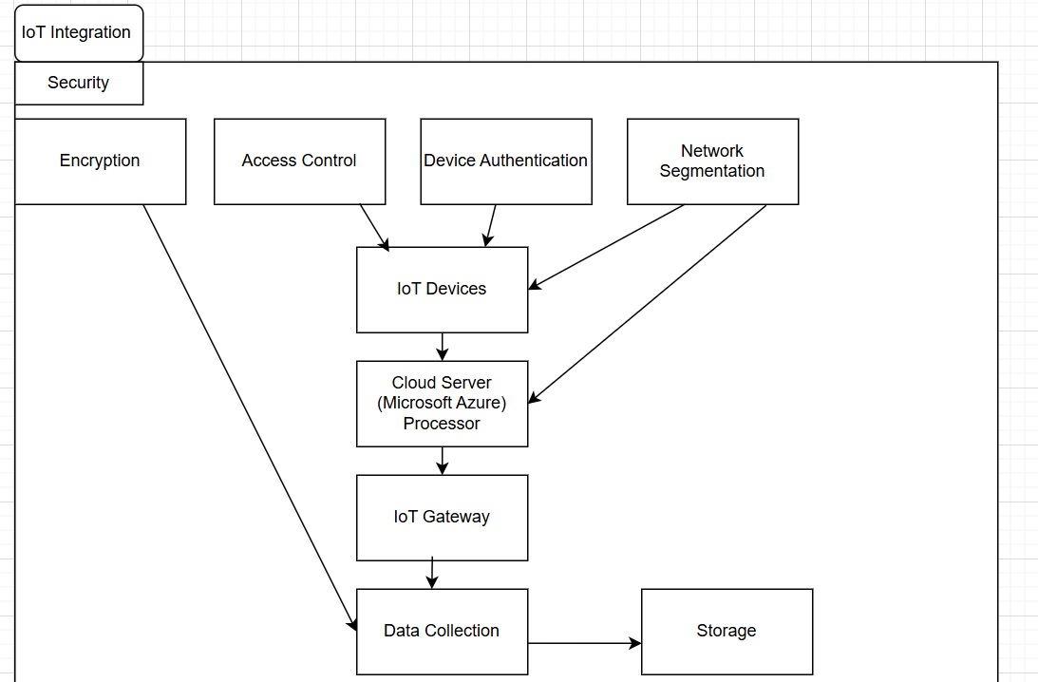

**Fig: IoT Integration Plan**

The security architecture for incorporating Internet of Things (IoT) devices into KN University's network is illustrated in the diagram. Access control to guarantee that only authorised users can interact with the system, device authentication to confirm that only authentic devices connect to the network, and encryption to safeguard data from unauthorised access are security measures for KN University's IoT integration. By isolating IoT devices, network segmentation further improves security by reducing the effect of potential intrusions. All these steps work together to guarantee the safe processing of the data generated by IoT devices and their safe operation throughout the campus.

The image above essentially shows how KN University uses segmentation, access control, authentication, and encryption in conjunction with cloud computing and safe data storage to guarantee the security and appropriate management of its IoT devices and the data they produce.

**Components:**

**IoT Device Types:**

Smart Lighting: Computerized and energy-proficient lighting frameworks.

Natural Sensors: Temperature, humidity, and air quality sensors. Example: D23-NB NB-IoT Waterproof Temperature Sensor with cost $179

Smart Lock Frameworks: Access control for buildings and rooms. Example: Igloohome Bluetooth Smart Deadbolt 2S Dark Grey Airbnb with cost $279

Study hall management: Smart projectors, intuitive whiteboards, and attendance systems. Example: BenQ MX560 High Brightness High Contrast Projector with cost $649

**Network Division:**

Dedicated IoT VLAN: Disconnect IoT traffic from general network traffic to improve security and execution.

Firewall Rules: Carry out rules to confine communication between IoT gadgets and basic network segments.

**Information Collection and Management:**

IoT Gateway: Gather information from IoT gadgets and forward it to the data centre or cloud.

Data Storage: Utilize databases or cloud administrations for putting away IoT information.

**Safety measures:**

Device Verification: Guarantee all IoT gadgets are validated prior to getting to the network.

Encryption: Encrypt data transmitted by IoT gadgets to safeguard against eavesdropping.

**Checking and Maintenance:**

IoT Monitoring Apparatuses: Execute tools to monitor the wellbeing and execution of IoT gadgets.

Regular Updates: Keep IoT gadget firmware and programming exceptional to address weaknesses.